NATO classification: Unclassified
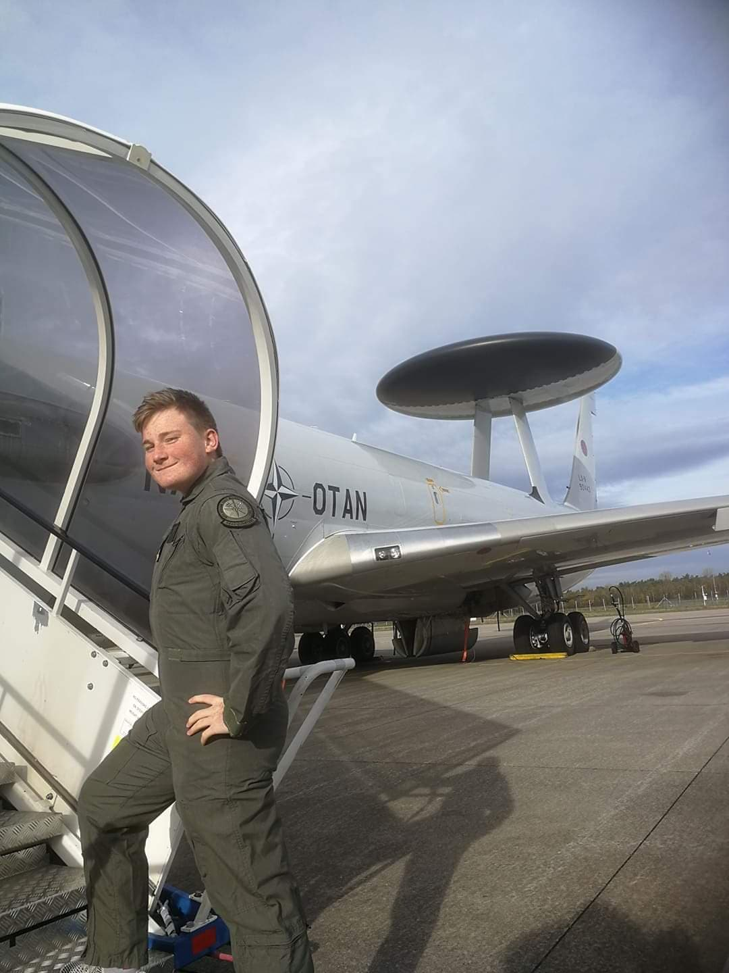 My name is Lucas, and I have recently been an intern at the NATO Airborne Warning and Control System or short: AWACS. The base where the planes are located in Geilenkirchen which is a city in Germany. The base lies close to the Netherlands, and when you take off from runway 27 you are in the Netherlands.
A lot of the things I have experienced are unfortunately classified, and therefore im not able to give a fully detailed logbook, but I can tell a lot about it.
I lived with a Danish family, who has been living there for 2x4 years, because the man has worked there twice, and the period is 4 years. By them living there for so long, and their kids going to German school they have made a big effort in teaching me the German culture, but in a way that its interesting for a Dane.
The day I arrived, we went to another Danes house, because he was turning 50 and I Germany when a person turns 50 years old, they get a doll with their face on it, and in a setting that they are interested in. For an example He got a doll with his face on it, dressed as a hunter, because his biggest hobby is hunting.
The following day, I was shown around in the base, which turned out to be huge, and has around 1500 employees around 15 E3A(AWACS) planes and 2-3 KC-135 tanker planes which are used to refuel the E3A’s.
While I was at the base, I tried a lot of stuff, for an example I was with the IMP’s which is the International Military Police. While I was following them, I tried a body suit, which their dogs could attack, and I tried pepper spray the latter I cannot recommend.
While being down there I turned 18, and on my 18th birthday they had arranged a flight with the E3A where I got to sit in the cockpit all day, and experience an air refueling. Which is seen on the picture. This led to me officially being the youngest person to be onboard this aircraft midair, as you have to be 18 to fly with them.
The trip has definitely been worth it, as their Public affairs department is really happy with my personality, and invited me to work for them when I’m done with gymnasium, which I of cause said yes to, and currently we are working on a 2 year paid internship.
I would definitely recommend anyone to take part in this program, as it has ben a huge experience, unfortunately NATO is terminating their intern program, and even though I have experienced a lot of stuff normal interns don’t get to experience, I would have recommended doing the normal internship.

